FOCP C Programming Assignment
Question 3: 2235. Add Two Integers
Platform: LeetCode
Programming Language: C
Problem Statement URL:
https://leetcode.com/problems/add-two-integers/
Problem Statement
Given two integers num1 and num2, return the sum of the two integers.
Example 1:
Input: num1 = 12, num2 = 5
Output: 17
Explanation: 12 + 5 = 17.
Example 2:
Input: num1 = -10, num2 = 4
Output: -6
Constraints:
- -100 <= num1, num2 <= 100
Source Code
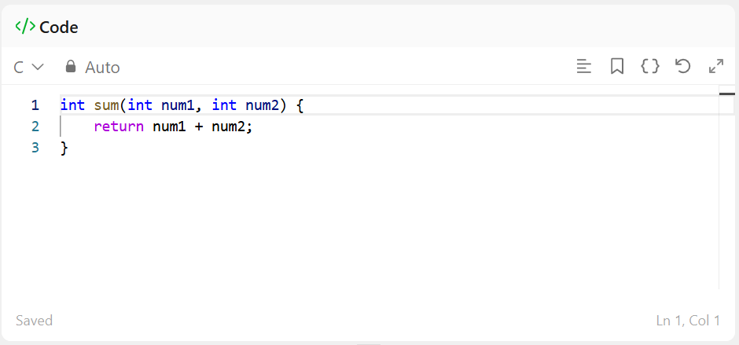

sOutput
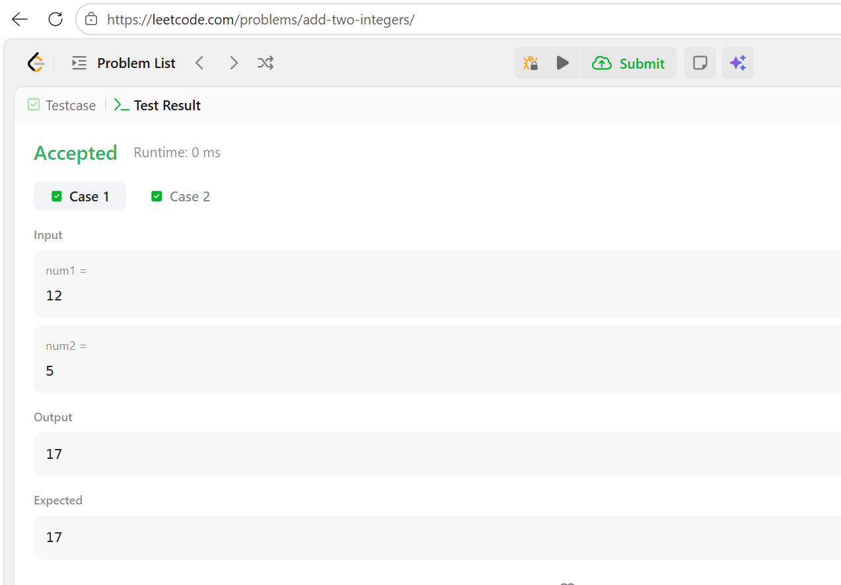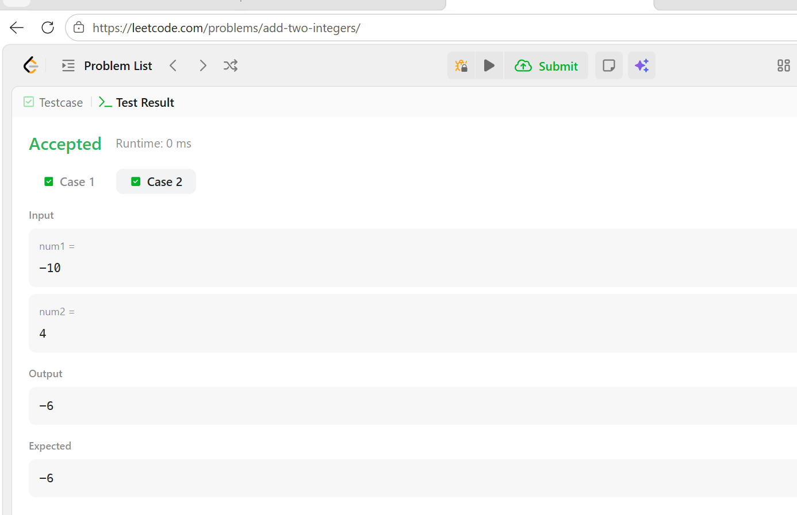
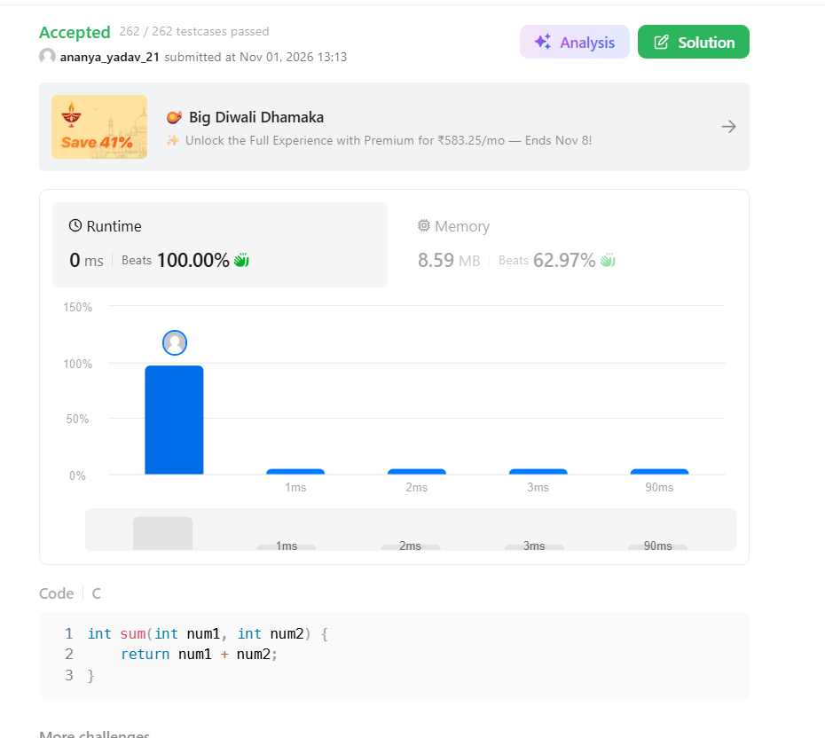Result
The program was executed successfully, and the solution was accepted on LeetCode.

